This is the pre-peer reviewed version of an article published in the Journal of Poverty and Social Justice. The definitive publisher-authenticated version of “Beyond 'mythbusting': how to respond to myths and perceived undeservingness in the British benefits system” in the Journal of Poverty and Social Justice, 24:291-306 is available at http://doi.org/10.1332/175982716X14721954314968.

Beyond ‘mythbusting’: how to respond to myths and perceived undeservingness in the British benefits system

Abstract
In a context of ‘hardening’ attitudes towards benefit claimants in Britain, some argue that social security can only be rebuilt when ‘benefit myths’ and negative attitudes are tackled. However, this paper argues that some of these concerns are misplaced, based on evidence on (i) the extent of myths; (ii) the effectiveness of mythbusting; and (iii) the existence of myths/negative attitudes in times/places the benefits system is more popular. It argues that public attitudes are fundamentally characterised by ambivalence, and the critical issue is the balance between positive and negative aspects and which of these are triggered in public debate.

Introduction
Labour’s defeat in the 2015 British General Election can be explained by a great many factors, as the official post-mortem (the ‘Beckett report’) makes clear. However, when the Beckett report was published, the headlines in the left-wing newspapers consistently settled on the party’s lack of trust by the public on ‘welfare’ as a key explanation for their dismal election result (alongside parallel concerns about the economy and immigration). This reflects a much wider preoccupation on the British left in recent years (not just within the Labour Party) about how to respond to public attitudes towards the benefits system, which are generally perceived to be both harsh and based on ‘myths’ fuelled by politicians and the media, leaving the public fundamentally at odds with left-wing values (e.g. Hills, 2014; Horton & Gregory, 2009; Taylor-Gooby, 2015). This potentially leaves progressives with a choice of either trying to correct the public’s myths, or simply accommodating their policy agenda to a view of the world that they do not share.
In this paper, however, I want to argue that some of these concerns are misplaced, bringing together several different pieces of empirical evidence (some from myself, some from others) that have not previously been integrated. To be absolutely clear: the British public do believe myths, and they are also more negative about benefit claimants than they used to be, as I will show. Yet this does not mean that ‘mythbusting’ is the best way of getting public support for progressive benefit reforms. While myths are associated with negative perceptions of claimants, it is not necessarily the case that this is because of a causal effect of benefit beliefs – and even if it is, there is considerable evidence leading us to doubt that mythbusting would directly change this. Moreover, such attitudes are not what primarily sets us apart from times and places where there is more public support for the benefits system. Instead, what is crucial is how far the public focus on the positive consequences of the benefits system, and how much we focus on the (widely-perceived) public vs. negative consequences in our public debates.

Myths and deservingness judgements in 21st-century Britain
There are two parts to the prevailing view of benefit attitudes in Britain. Firstly, the idea that public attitudes have become more hostile is, as Hudson and Lunt (in press) put it, “now close to an orthodox view.” This is hardly surprising in the face of newspaper headlines that have regularly proclaimed that attitudes towards benefit claimants are ‘hardening’, often based on the latest launch of the high-quality and widely-publicised annual British Social Attitudes (BSA) survey. And this consensus is not completely divorced from the empirical reality: attitudes towards unemployment benefit claimants have definitely hardened, and noticeably fewer people believe that the government should spend more on ‘welfare benefits for the poor’ (Clery, 2012; Taylor & Taylor-Gooby, 2015), as illustrated in Figure 1 below.
Yet the existence of this decline can blind us to the nuances of shifts in public opinion. Comparing current views to the late 1980s, the numbers saying that ‘most people on the dole are fiddling in one way or another’ or that ‘many people who get social security don’t really deserve any help’ has barely risen (Taylor & Taylor-Gooby, 2015), as also shown in Figure 1. Moreover, it is still the case – despite the financial crisis, and despite hardening attitudes to unemployed people – that more people agree than disagree that the Government should raise ‘welfare benefits for the poor, even if it means higher taxes’ (see AUTHOR REF and below). There is some truth to the idea that attitudes to the benefits system have hardened, but the scale and uniformity of these shifts is perceived to be considerably greater than the evidence bears out.
Figure 1: Trends in benefit attitudes in Britain since 1983
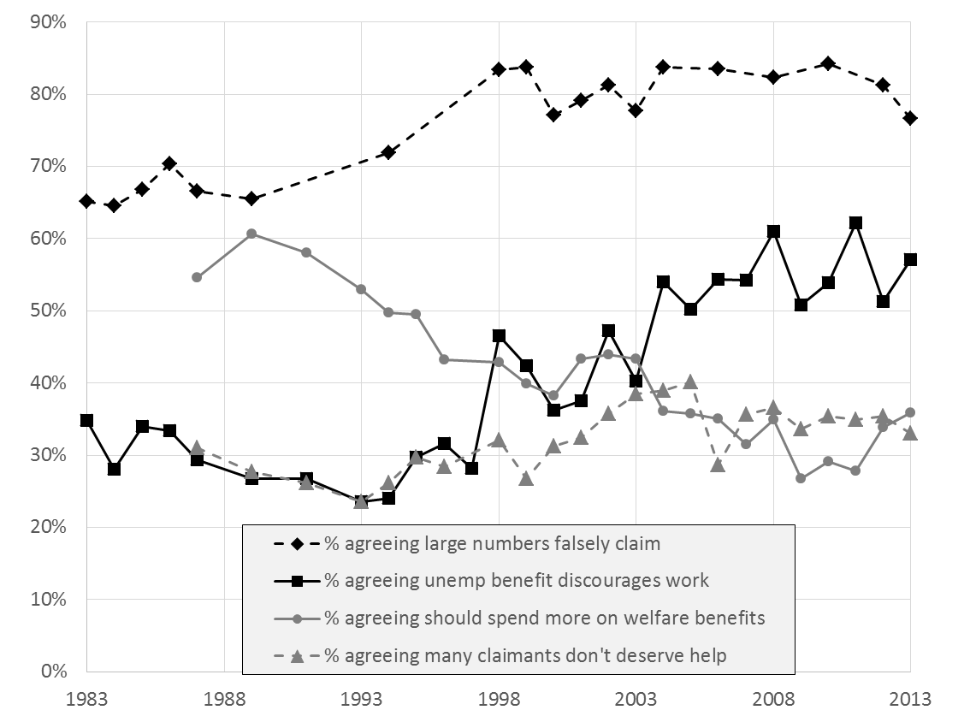
Source: British Social Attitudes survey (see AUTHOR REF #4 for further details).

The second part of the prevailing view of British attitudes is that the public do not have an accurate view of the benefits system, instead believing ‘myths’ (often argued to be spread by parts of the press; see Baumberg et al., 2012). This is not just a view of think-tanks and campaigning organisations, but is also shared by notable academics such as John Hills (2014) and Peter Taylor-Gooby (2015) among others. It is also supported by the empirical evidence, if anything even more strongly than increasing hostility towards benefit claimants. In a separate paper I systematically reviewed 46 beliefs across 18 datasets, and compared these to the best available data on the true picture (AUTHOR REF). My overall conclusion was that the British public do indeed have low levels of understanding of the benefits system, primarily in ways that would seem to imply that claimants are undeserving:
- People wildly overestimate how much is spent on unemployment benefits compared to pensions. They also overestimate other related aspects of unemployment benefits (how much claimants without children receive, and the proportion of the population that is unemployed).
- Half the population believe out-of-work benefit claims have risen in the past fifteen years, when they have actually fallen noticeably.
- It is difficult to know the true level of benefit fraud – but the Government’s extensive attempts to estimate the level of probable fraud suggest low levels, and even assuming this is a lower bound, the public overestimate fraud compared to any reasonable figure.
- On almost no measure do more than one-third of individuals give a correct answer as I define it (allowing some room for uncertainty / rounding in people’s numeric responses).
Inevitably there are further important nuances here. The public are in fact relatively accurate on average when estimating the share of the working-age population who currently claim out-of-work benefits (and within this, nearly one in four people provide underestimates rather than overestimates). People also tend to underestimate how much certain sorts of claimants receive, believing the system is less generous to pensioners and unemployed people with children than it really is. And it is important to avoid a false air of absolute certainty around these myths; the true figures are often uncertain, and people’s beliefs are obtained from sample surveys (often web panels) in which response biases are likely. Still, these nuances aside, in general the evidence strongly supports the assumption of widespread myths.

The role of mythbusting
My critique in this paper is not with the view that we have seen declining support for benefits claimants and widespread myths, which as we have seen, is broadly correct. Instead, my concern is with the implications that are taken from this, and in particular the idea that ‘mythbusting’ is the best way of getting public support for progressive benefit reforms. It is important not to construct a straw man here; Hills (2014) and Peter Taylor-Gooby (2015) are not naively arguing that mythbusting is the panacea for all public concerns. Yet the need to tackle misperceptions is a common theme in progressive debate, and sometimes is central: for example, an article in the Guardian newspaper argues that “it is perhaps this ignorance [of the welfare state] which is putting the survival of a safe system of support for the population at especial risk” (Beresford, 2013), while the Independent newspaper contained a headline, “Voters ‘brainwashed by Tory welfare myths’, says new poll” (Grice, 2013). More broadly, ‘mythbusters’ are commonly used as an element in campaigning (among many others, see Baptist Union of Great Britain et al., 2013; Coote & Lyall, 2013).
A minor problem with this argument is its assumption that there is a causal link between people’s beliefs about the benefits system and their deservingness judgements. This is plausible in the light of the empirical literature, but with caveats. In a separate analysis (AUTHOR REF #2), I show that beliefs about the benefits system are often strongly associated with deservingness judgements, even after controlling for political preferences and sociodemographic factors (education, working status, region, age and gender). One way of expressing this relationship is via a method that Sturgis (2003) terms ‘simulation’, which estimates what the population’s attitudes would be if their knowledge was uniformly correct (a technique often used to simulate people’s voting behaviour if they had correct knowledge about each party’s positioning). A selection of the simulation results from AUTHOR REF #2 are shown below in Table 1.
Table 1: Simulated population-level deservingness perceptions if people held correct beliefs about the benefits system
Belief question | Deservingness question | ∆agree  if all correct
Perceptions of benefit fraud
Fraud as % of welfare spending ⁽¹⁾ | Dependency culture | -8.1%**
Perceptions of spending on benefits
Unemp as % of welfare budget | Dependency culture | -11.4%**
Perceptions of level of claims among working-age population
Long-term sick & disabled as % of pop | Many not entitled | -7.4%**
Unemployed & looking for work as % of pop | Many not entitled | -6.5%**
Perceptions of value of benefits
£ unemp benefit, couple+2 kids ⁽¹⁾ | Dependency culture | 0.0%
£ incentive to take min wage job‡ | Dependency culture | 0.3%
Table adapted from AUTHOR REF #2. Key: ** p<0.01, * p<0.05, + p<0.10; ‡ Major issues around the 'true' figure given, ⁽¹⁾ Minor issues about the 'true value' given. Models control for sex, age, age², region, education, economic activity, and political affiliation (see AUTHOR REF #2 for further details).
For example, this shows that if people knew the correct proportion of welfare spending that was fraudulent – taking ‘correct’ to be 10% of claims to allow for hidden fraud and a margin of error, but noting that this is considerably higher than the government’s extensive fraud-checking suggests – then 8.1% fewer people would agree that there is a ‘dependency culture’. Overall, the models suggest that for most beliefs, if people’s knowledge was correct then 5-10% fewer would agree that claimants are undeserving. However, beliefs about the level of benefits that claimants receive, or their incentive to work, have no relationship with deservingness judgements. This is unexpected, but confirms that “some facts are more valid and pertinent than others”, as Kuklinksi et al (1998) put it.
Despite this pattern of associations, there are reasons to doubt that mythbusting will change wider attitudes. People tend to selectively expose themselves to information (Hart et al., 2009) – and to interpret the information they do receive (Taber et al., 2009) – in ways that support their existing attitudes. To the extent that we see that people with certain beliefs also hold certain attitudes, then this may indicate that their attitudes determine their beliefs rather than vice versa. Mythbusting may also backfire as talking about a myth that is closely linked to a particular ‘frame’ may simply support that framing, pithily summarised by Lakoff (2014) as ‘don’t think of an elephant!’. Talking repeatedly about the ‘myth of widespread benefits fraud’ may simply encourage the public debate to centre on such fraud, both cementing misperceptions and leading to negative attitudes (for a similar argument about anti-fraud policies, see e.g. AUTHOR REF #3).
The greatest problem, though, is the assumption that mythbusting is an effective way of changing people’s beliefs – and here the evidence is even more dispiriting. Partly this is because “facts can be assimilated into the brain only if there is a frame to make sense out of them… The consequence is that arguing simply in terms of facts… will likely fall on deaf ears” (Lakoff, 2006). Changes in knowledge will therefore depend upon alternative (and truthful) frames, rather than disembodied ‘facts’. It is also partly because talking about myths – even to correct them – may backfire, because the familiarity of misperceptions may linger even after the detail of their inaccuracy fades (Peter & Koch, 2015). But more than this, the mythbusting itself may simply not be believed. Extensive evidence shows that people generally interpret any information they receive in ways that support their pre-existing beliefs, a much-researched phenomenon known as ‘motivated reasoning’ (Taber et al., 2009).
Theoretically, then, it is hard to tell a priori if mythbusting will have an impact on either beliefs or attitudes, and we must therefore look empirically at recent survey experiments see how these potential mechanisms play out in practice. A cornerstone of the mythbusting literature is Nyhan & Reifler (2010), who show that mythbusting can fail or even backfire across several policy issues (Iraq, stem cell research, and tax cuts). However, an alternative interpretation of the Nyhan & Reifler study is that it provides relatively weak knowledge interventions (none of which seem to influence centrists). Other research in the same vein has been more mixed, with some showing similar results (Peter & Koch, 2015) but others finding that mythbusting can be effective (in the case of Fridkin et al., 2015 by showing that fact-checks sway people's interpreation of campaign adverts).
Related to this, there is a growing literature on the impact of information per se (rather than mythbusting) on attitudes, which also seems to suggest that it is possible to deliberately increase people’s knowledge and change their attitudes in certain situations. Kuziemko et al (2015) found that giving people inequality-related information made them much more likely to agree that inequality was a serious problem and support a higher estate tax (but had no impact on support for other policy proposals such as a higher millionaire tax). In contrast, Lawrence & Sides (2014) found no impacts of giving people a varied list of statistics on their policy attitudes. Overall, Lawrence & Sides (2014)’s conclusion seems reasonable: “providing knowledge can, but does not necessarily, change people’s minds about political issues.” It is also worth noting that these survey experiments are a slightly artificial design that is likely to overestimate the real-life, longer-term impacts of mythbusting (Barabas & Jerit, 2010).
There are therefore both theoretical and empirical reasons to doubt that mythbusters will have a strong impact on attitudes – but it is the evidence directly on benefits that is the most damning. , The one survey experiment specifically on benefits found that information had no impact on people’s support for benefits-related policies (Kuklinski et al., 2000). Similarly, repeated qualitative studies in the UK have presented people with factual information (often about benefit fraud), and found that it is simply not believed by participants. The following quotes are entirely consistent:
- “In cases where the evidence appeared to contradict their original views, participants typically dismissed the evidence as ‘government propaganda’ or ‘newspaper talk’” (Knight, 2015).
- DWP fraud statistics were disbelieved in an Ipsos MORI/Demos study, who quoted one respondent saying, “How do they get these figures then? Is it because they don’t want people to know that their system is rubbish and that they’re being conned? Because we’re being conned all over the place with immigration, the whole lot, so I don’t think I’d trust the figures” (Duffy et al., 2013).
- “Against the backdrop of deep levels of distrust in public institutions, particularly government, official statistics are, at the best of times, easy to dismiss. When these statistics also attempt to tackle head-on these deeply held, often emotionally-driven views, they are frequently rejected” (Mattinson, 2014:51).
- Fabian Society/Crisis did find that some statistics – such as a growth in housing benefit claims among working people – had some resonance, but in the light of how people responded to other facts they nevertheless concluded that “in many cases, facts designed to counter negative views are unsuitable and ineffective on their own " (Doron & Tinker, 2013).
- This consistent finding extends to the occasional reflection on the impact of benefits mythbusters in practice. One charity (the Webb Memorial Trust) described their wider attempt at publishing a mythbusting supplement in the New Statesman magazine, which “was well received – but only by people who were already well informed. There is no evidence to date to suggest that we have changed anyone’s mind” (Knight, 2015).
Those who have experimented with mythbusting therefore conclude that progressives should “resist bombarding the public with stats. The successful ‘scrounger’ narrative is rooted in anecdote, stories and symbols, not statistics.” (Mattinson, 2014), or more succinctly, “foster conversations, don’t just dispense facts" (Doron & Tinker, 2013). In the light of this evidence (and parallel experiences while campaigning), some commentators have similarly argued that “fact-busting has its limits” (Moore, 2013) and are sceptical of the value of “bombarding the electorate with statistics that don’t resonate” (Jones, 2016).
This is not to suggest that mythbusting should be altogether abandoned. A more recent study by Nyhan & Reifler (2014) conducts a more naturalistic experiment to see if drawing state legislators’ attention the Pullitzer-winning ‘Politifact’ operation leads them to make fewer claims that are later fact-checked and found to be untrue. While the numbers of claims that are fact-checked by Politifact is relatively small over this period and the analyses therefore low-powered, there is some suggestive evidence that there is an effect. Mythbusting may therefore contribute to a more truthful public debate, and have an indirect impact on public attitudes via the behaviour of elected representatives and other prominent public figures. But in the light of the evidence, it seems a distant hope that mythbusting will have substantial direct effects on the public’s knowledge and attitudes on benefits.

Myths and deservingness judgements in other times and places
If mythbusting is likely to fail (at least in terms of its more grandiose aims), then British progressives may resign themselves to the impossibility of progressive reforms in the midst of a hostile public debate. Yet this too relies on a faulty assumption about the difference between contemporary Britain and other times and places in which the benefits system is more generous. In this section, I show that judgements of undeservingness (and where data exists, myths) also exist in post-war Britain and Scandinavia today.

Post-war Britain
The period from the end of World War Two to the rise of Thatcher is typically viewed as the time of post-war consensus (a view largely but not unanimously supported by historians; see Bochel & Defty, 2007), a golden age of support of social security to be contrasted with present day cuts and public concerns. However, the implicit contrast to postwar Britain is rarely made explicit, and the reality is that perceptions of undeserving benefit claims have a long history.
Hudson and Lunt (this volume) observe that most tales of declining support start in the 1980s, simply because this is when the BSA series begins. Yet if we look back further, we see that this is only a short time after a ‘violent upsurge in anti-welfare feelings’ (Golding & Middleton, 1982:157) that Alan Deacon at the time labelled ‘scroungerphobia’ (Deacon, 1978). This is borne out by the limited survey data that exist: for example, a 1977 survey (Golding & Middleton, 1982:185) found that nearly everyone – 97.7% of respondents in their two areas – agreed that 'It is sometimes said that some people who get social security are just scroungers. Do you think there are people like that?’. The perceived prevalence of such ‘scroungers’ is remarkably similar to responses to present-day polls .
This comes at (or perhaps just after) the end of the postwar consensus, but Hudson & (this volume) suggest the public were not unequivocally supportive of the benefits system even before this. For example, they show that large majorities in the 1960s agreed that ‘many people are drawing supplementary benefit/national assistance who could really be earning enough to support themselves if they wanted to’, and that there was considerable support for benefits for groups thought to be deserving (e.g. ‘old people living alone’, disabled people) but little support for those judged undeserving (e.g. ‘men who are homeless because they are alcoholics’, ‘deserted wives’). And even before this, there is a long history of negative newspaper reporting and stigmatising policies for benefit claimants that previous social policy scholars (e.g. Golding & Middleton, 1982; Page, 1984:25) have extensively documented.
There is little direct survey evidence on the public’s knowledge (rather than attitudes) in the past, but the evidence that exists further suggests that the public have never been particularly well-informed. Golding & Middleton (1982) found that an outright majority overestimated a hypothetical family’s income on Supplementary Benefit in 1977, with nearly one-quarter estimating benefits to be one-third higher than reality. However, perceptions of the level of unemployment seemed to be reasonably accurate (Golding & Middleton, 1982:174). Hudson & Lunt’s review of even earlier survey data (this volume) finds that public understanding of social security in 1968 was confused, and even understanding of the famous Beveridge Report in 1942 was limited. It is difficult to know whether these levels of knowledge are higher or lower than today, but it is clear that benefits knowledge has long been imperfect.

Scandinavia today
The other implicit contrast made by British progressives is with Scandinavia (i.e. Norway, Sweden and Denmark), in which there is a considerably more generous benefits system, and where attitudes are felt to be much more supportive. Yet such views often gloss over the perceptions of undeservingness that exist in Scandinavia. For example, 68-73% of people in Scandinavian countries say that people often look down on social assistance claimants (Albrekt Larsen, 2006:Table 6.2), and European Social Survey (ESS) data from 2008 show that 29-43% of Scandinavians agree that social benefits/services make people lazy, while 32-51% agree that many people manage to obtain benefits/services that they are not entitled to (see also Halvorsen, 2002). Scandinavians also have imperfect knowledge of their benefits system, or at least of their unemployment and long-term sickness rates (the only measure for which we have comparative data), with only around half of respondents managing to provide a roughly correct answer (see Appendices to AUTHOR REF #2).
In fact, if we look across European countries, the perception of negative economic and moral consequences is higher in those countries that have higher social expenditures (van Oorschot et al., 2012:192). The perception of negative consequences across each country in the ESS is shown below in Figure 2, and highlights that the Scandinavian countries are unexceptional in their perception of negative consequences; it is clearly not the case such attitudes present an insurmountable barrier to more generous welfare states. What van Oorschot et al make clear, however, is that the perception of positive consequences of the welfare state – preventing widespread poverty, creating a more equal society, and helping people combine work and family – is higher still in these countries. As they put it, “a higher spending welfare state promotes its social legitimacy by stimulating in people the idea that it is doing a good job, more than that it arouses their worries about its effect on the economy and morals.”
Figure 2: Perceived positive and negative consequences of the welfare state across Europe
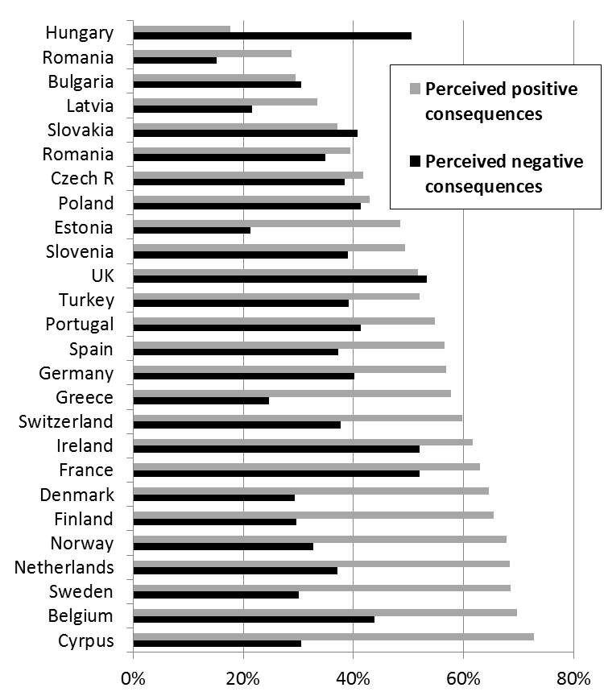
Adapted from van Oorschot et al (2012). Data are own analyse of ESS 2008 data; bars show the average share of the population agreeing that the welfare state has certain negative consequences (placing too great a strain on the economy, costing businesses too much in taxes/charges, making people lazy, making people less willing to care for one another, making people less willing to look after themselves/family) and certain positive consequences (preventing widespread poverty, leading to a more equal society, making it easier to combine work & family). Again, it is important to be clear on my argument here. I am not claiming that negative attitudes towards benefits are equally high in Scandinavian countries as the UK, as Figure 2 makes clear (indeed, the same ESS data shows that 66% of Britons think that social benefits/services make people lazy, and 70% agree that many people manage to obtain benefits/services they are not entitled to). Nor am I claiming that Scandinavian perceptions of their benefits system are as erroneous as British perceptions (Britons perceive higher levels of unemployment and long-term sickness compared to Swedes, for example, despite Sweden having higher levels of both; AUTHOR REF #2). Instead, I want to make clear that myths and perceptions of undeservingness are not unique to the UK, and can be found even in times and places in which the benefits system is much more generous. What is different in such settings is not whether such ideas exist to any great extent in society, but how widespread they are, and how far they are balanced by widespread perceptions of more positive consequences of the welfare state.

The ambivalence of benefits attitudes
What characterises attitudes to the benefits system, above all, is ambivalence. This seems to be true of all countries at all times – even when the benefits system is generous and popular, many people still have some concerns, as the previous section has shown. The same is true in reverse for 21st century Britain: even though attitudes are usually felt to be predominantly hostile, many people have positive elements to their attitudes to the benefits system. For example, when last asked (in 2003), over half of people said that they were proud of Britain’s social security system (and not just proud about the welfare state in general). Nearly 80% people agree that large numbers who are eligible for benefits fail to claim them (both from BSA data in AUTHOR REF 2012). And there is relatively widespread agreement in the ESS data in the previous section that the benefits system has positive consequences in preventing widespread poverty (57%) and helping people combine work and family (58%).
Another way of expressing this ambivalence is to look within a single country at how far groups perceived to be deserving are supported compared to groups perceived to be undeserving. In the UK in 2013, far more people thought there should be less spending on unemployment benefits than though that spending should rise (49% less vs. 15% more). Yet the same respondents also overwhelmingly thought there should be more spending on retired people (7% less vs. 48% more) and disabled people who cannot work (4% less, 54% more) (AUTHOR REF #4). This has visible impacts on political debate, most recently with the (right-wing) Government’s attempt to cut a (non-work-related) disability benefit by tightening the eligibility criteria. This faced overwhelming public disagreement (two polls at the time put opposition to the policy at 70% and 84%) and seems to have been scrapped in the light of a backbench rebellion and the (partially-attributable) resignation of the Secretary of State (against what he argued to be a policy imposed by the Treasury).
Such differentiation according to deservingness judgements is by no means limited to the UK; indeed, Wim van Oorschot has influentially argued that there is a universal ranking of different claimant groups from most deserving to least deserving (van Oorschot, 2006). Aarøe & Petersen (2014) have likewise argued that both Americans and Danes show a similar ‘deservingness heuristic’, with citizens of both countries making similar judgements about whether hypothetical claimants are worthy of support when given detailed information about them (e.g. “Imagine a man who is currently on social welfare. He has never had a regular job, but he is fit and healthy. He is not motivated to get a job” vs. “Imagine a man who is currently on social welfare. He has always had a regular job, but has now been the victim of a work-related injury. He is very motivated to get back to work again”). It is only when people are asked to form an opinion about benefits claimants in the absence of contextual information that the expected US-Denmark differences are visible.
The challenge in the UK is therefore not that negative attitudes exist, nor that there is little support for claimants who are seen to be undeserving, nor even that there is ambivalence about the benefits system – for all of these are universal. Rather, the challenge is that public debate about benefits emphasises the negative side of this ambivalence at the expensive of the positive side, and emphasises undeserving claimants over deserving ones. Hence in Figure 2, the balance of positive vs. negative perceived consequences of the welfare state is higher in the Scandinavian countries than nearly any other European country, while the UK in contrast has the most negative perceived balance of any country barring Slovakia and Hungary (van Oorschot et al., 2012:188). This is reflected in media coverage: stories about benefits in Britain are split between the positive and negative, while stories in the Scandinavian press are usually positive (Larsen & Dejgaard, 2013).

Conclusion
In this article, I have argued that some of the concerns of British progressives about how to respond to myths and harsh benefit attitudes are misplaced. It is true that many benefit myths are widespread in Britain, and that claimants are perceived more harshly than twenty or thirty years ago – and there are also some signs that these myths and harsh attitudes are linked. However, it is doubtful that ‘mythbusting’ will have large impacts on either of them. Moreover, it is not clear that progressive benefits system reforms depend on wiping out either myths or perceived undeservingness, as these can be found in more generous benefit systems ranging from post-war Britain to present-day Scandinavia. At the population level, people are fundamentally ambivalent about benefits systems, and what is critical is the balance between the positive and negative aspects of this ambivalence. This is a different starting point than most current debates on benefits in Britain, but one that is borne out by the evidence, and takes the debates in a different direction.
This obviously leaves the question of how to influence this balance – but to avoid repeating an argument I have previously made, I will only summarise this briefly here (for a fuller argument, see AUTHOR REF 2012). The cornerstones of debates about benefits are often set by the benefits system itself: some systems ‘open up’ questions of deservingness, while others close them down (Albrekt Larsen, 2006). There still leaves some space to ‘reframe’ debates to support progressive reforms (Lakoff, 2014), but these need to resonate with people’s existing beliefs, which are in turn partly structured by the present system. While it is therefore impossible to take progressive leaps at first, it may be easier to take a series of small steps that successively unlock the possibility of hitherto impossible changes. This requires a long-term vision allied to an acute political sense; as Margaret Thatcher once said, “it isn't that I set out on economic policies… Economics are the method; the object is to change the heart and soul” (Thatcher, 1981).

Bibliography
Aarøe, L., & Petersen, M. B. (2014). Crowding out culture: Scandinavians and Americans agree on social welfare in the face of deservingness cues. The Journal of Politics, 76(03), 684-697
Albrekt Larsen, C. (2006). The institutional logic of welfare attitudes: how welfare regimes influence public support Aldershot: Ashgate.
Baptist Union of Great Britain, the Methodist Church, the Church of Scotland, & the United Reformed Church. (2013). The lies we tell ourselves: ending comfortable myths about poverty. London: Methodist Publishing
Barabas, J., & Jerit, J. (2010). Are Survey Experiments Externally Valid? American Political Science Review, 104(2), 226-242
Baumberg, B., Bell, K., Gaffney, D., with Deacon, R., Hood, C., & Sage, D. (2012). Benefits stigma in Britain. London: Elizabeth Finn Care/Turn2us. http://www.turn2us.org.uk/about_us/media_centre/news_archive/benefits_stigma.aspx
Beresford, P. (2013). Why welfare literacy is vital. The Guardian 30/1/2013. http://www.theguardian.com/social-care-network/2013/jan/30/welfare-literacy-state-support
Bochel, H., & Defty, A. (2007). MPs' Attitudes to Welfare: A New Consensus? Journal of Social Policy, 36(01), 1-17
Clery, E. (2012). Are tough times affecting attitudes to welfare? In A. Park, E. Clery, J. Curtice, M. Phillips, & D. Utting (Eds.), British Social Attitudes: the 29th Report. London: NatCen Social Research.
Coote, A., & Lyall, S. (2013). “Strivers v. skivers: the workless are worthless”. London: nef (the new economics foundation) and the Tax Justice Network
Deacon, A. (1978). The Scrounging Controversy: Public Attitudes Towards the Unemployed in Contemporary Britain. Social Policy & Administration, 12(2), 120-135
Doron, N., & Tinker, R. (2013). Home Truths: how to change attitudes about housing benefit: Fabain Society and Crisis. http://www.crisis.org.uk/data/files/publications/Home_Truths%20Final.pdf
Duffy, B., Hall, S., O’Leary, D., & Pope, S. (2013). Generation Strains: a Demos and Ipsos MORI report on changing attitudes to welfare. London: Demos. http://www.demos.co.uk/files/Demos_Ipsos_Generation_Strains_web.pdf?1378677272
Fridkin, K., Kenney, P. J., & Wintersieck, A. (2015). Liar, Liar, Pants on Fire: How Fact-Checking Influences Citizens’ Reactions to Negative Advertising. Political Communication, 32(1), 127-151
Golding, P., & Middleton, S. (1982). Images of welfare: press and public attitudes to welfare. Worcester: Billing & Sons Limited.
Grice, A. (2013). Voters 'brainwashed by Tory welfare myths', shows new poll. Independent 4/1/2013. http://www.independent.co.uk/news/uk/politics/voters-brainwashed-by-tory-welfare-myths-shows-new-poll-8437872.html
Halvorsen, K. (2002). Solidarity and the legitimacy of the welfare state: Attitudes to abuse of welfare benefits in the Scandinavian countries. COST A13 Project meeting "Changing labour markets, welfare policies and citizenship', Florence, 31/5/2002-1/6/2002. http://www.socsci.auc.dk/cost/unemployment/Florence2002/KnutHalvorsen.PDF [accessed 11/12/2011]
Hart, W., Albarracín, D., Eagly, A. H., Brechan, I., Lindberg, M. J., & Merrill, L. (2009). Feeling validated versus being correct: a meta-analysis of selective exposure to information. Psychological Bulletin, 135(4), 555
Hills, J. (2014). Good times, bad times: The welfare myth of them and us. Bristol: Policy Press.
Horton, T., & Gregory, J. (2009). The Solidarity Society. London: Fabian Society.
Jones, O. (2016). The left must not fear the Beckett report – it will help Labour win power. The Guardian 18/1/2016. http://www.theguardian.com/commentisfree/2016/jan/18/labour-beckett-report-left-election-defeat-2015
Kellner, P. (2012). A Quiet Revolution. Prospect Magazine February 22. http://www.prospectmagazine.co.uk/features/a-quiet-revolution-britain-turns-against-welfare
Knight, B. (2015). The Society We Want. London: Webb Memorial Trust
Kuklinski, J. H., Quirk, P. J., Jerit, J., Schwieder, D., & Rich, R. F. (2000). Misinformation and the Currency of Democratic Citizenship. The Journal of Politics, 62(3), 790-816
Kuklinski, J. H., Quirk, P. J., Schwieder, D. W., & Rich, R. F. (1998). " Just the Facts, Ma'am": Political Facts and Public Opinion. The Annals of the American Academy of Political and Social Science, 143-154
Kuziemko, I., Norton, M. I., & Saez, E. (2015). How Elastic Are Preferences for Redistribution? Evidence from Randomized Survey Experiments. American Economic Review, 105(4), 1478-1508
Lakoff, G. (2006). Thinking points: Communicating our American values and vision. Macmillan.
Lakoff, G. (2014). The All New Don't Think of an Elephant!: Know Your Values and Frame the Debate. Chelsea Green Publishing.
Larsen, C. A., & Dejgaard, T. E. (2013). The institutional logic of images of the poor and welfare recipients: A comparative study of British, Swedish and Danish newspapers. Journal of European Social Policy, 23(3), 287-299
Lawrence, E. D., & Sides, J. (2014). The consequences of political innumeracy. Research & Politics, 1(2), 2053168014545414
Mattinson, D. (2014). Making the case for supporting the most vulnerable. In E. Wallis & O. Hilbery (Eds.), Within Reach: the new politics of multiple needs and exclusions (pp. 47-55). London: Fabian Society.
Moore, S. (2013). 'Welfare' cuts: how the right gets the public on its side. The Guardian 2/4/2013. http://www.theguardian.com/commentisfree/2013/apr/02/welfare-cuts-public-on-rights-side
Nyhan, B., & Reifler, J. (2010). When corrections fail: The persistence of political misperceptions. Political Behavior, 32(2), 303-330
Nyhan, B., & Reifler, J. (2014). The Effect of Fact‐Checking on Elites: A Field Experiment on US State Legislators. American Journal of Political Science
Page, R. (1984). Stigma. London: Routledge & Kegan Paul.
Peter, C., & Koch, T. (2015). When Debunking Scientific Myths Fails (and When It Does Not) The Backfire Effect in the Context of Journalistic Coverage and Immediate Judgments as Prevention Strategy. Science Communication, 1075547015613523
Sturgis, P. (2003). Knowledge and Collective Preferences: A Comparison of Two Approaches to Estimating the Opinions of a Better Informed Public. Sociological Methods & Research, 31(4), 453-485
Taber, C. S., Cann, D., & Kucsova, S. (2009). The Motivated Processing of Political Arguments. Political Behavior, 31(2), 137-155
Taylor-Gooby, P. (2015). Making the case for the welfare state. Policy & Politics, 43(4), 597-614
Taylor, E., & Taylor-Gooby, P. (2015). Benefits and welfare: long-term trends or short-term reactions? British Social Attitudes, 32
Thatcher, M. (1981). Economics are the method: The object is to change the soul. Sunday Times Interview May
van Oorschot, W. (2006). Making the difference in social Europe: deservingness perceptions among citizens of European welfare states. Journal of European Social Policy, 16(1), 23-42
van Oorschot, W., Reeskens, T., & Meuleman, B. (2012). Popular perceptions of welfare state consequences: a multi-level, cross-national analysis of 25 European countries. Journal of European Social Policy, 22(2), 181-197

See http://www.theguardian.com/politics/2016/jan/14/beckett-report-labour-lost-2015-election-economy-immigrants-benefits, http://www.mirror.co.uk/news/uk-news/devastating-beckett-report-reveals-labour-7206957, and http://www.independent.co.uk/news/uk/politics/jeremy-corbyn-hasnt-won-back-the-publics-trust-on-welfare-and-immigration-says-margaret-beckett-a6822306.html.
See http://blogs.spectator.co.uk/2009/02/hardening-attitudes-towards-welfare-make-reform-an-easier-sell/, http://www.bbc.com/news/uk-politics-21716638, and http://www.telegraph.co.uk/news/politics/labour/10055079/Labour-voters-harden-their-hearts-against-welfare.html
10% estimated that over half of claimants were scroungers, 30% said between a quarter and a half, around 35% said fewer than a quarter, and 25% said they didn’t know. While sampling and wording is different, these results are relatively close to a recent YouGov poll that asked people ‘Some people talk about ‘scroungers’ who lie about their circumstances in order to obtain higher welfare benefits (for example, by pretending to be unemployed or ill or disabled) or deliberately refuse to take work when jobs are available. How many welfare claimants, if any, would you sit fit this description?’, in which only 3% said that ‘very few, if any, are scroungers’, 25% said ‘a small minority’, 39% ‘a significant minority’, 22% ‘around half’, 7% ‘most welfare claimants’, and 5% said ‘don’t know’ (Kellner, 2012).
Authors own analysis of weighted ESS data.
See the YouGov poll 16-17 March at https://yougov.co.uk/news/2016/03/18/least-fair-budget-omnishambles/ and the Ipsos MORI poll 19-22/3/2016 at https://www.ipsos-mori.com/researchpublications/researcharchive/3713/George-Osbornes-satisfaction-ratings-equal-his-worst-ever-following-budget.aspx#gallery[m]/2/
See http://www.bbc.com/news/uk-politics-35848687

